Color Scheme

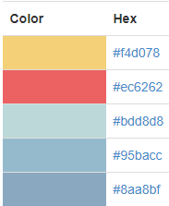

#f4d078

#ec6262 - Secondary

#bdd8d8

#95bacc – Primary

#8aa8bf

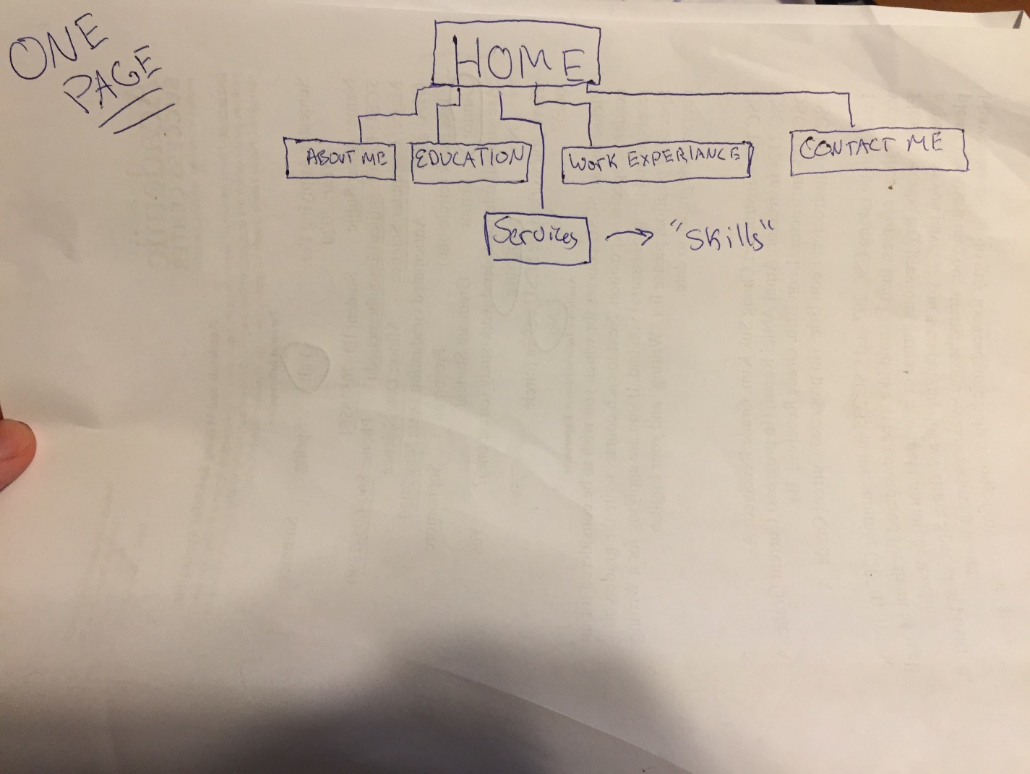Site Map

Layout

